=How to guide post template
Meta title  Character limit: (41/60) | Ultimate Guide to Baobab Powder | Baobest
Meta description  Character limit: (130/140) | Discover the benefits, uses, and market insights of baobab powder in our complete guide to this African superfruit. Visit Baobest.
Focus keyphrase | Baobab Powder
Suggested URL (52/60) | https://www.baobabfoods.com/blog/baobab-powder-guide
Keyword research sheet link | Keywords analysed - Baobest.xlsx  Keyword analysis - Baobab powder (fruit, powder, seed, etc) with general purchase intent.xlsx  Ultimate Guide To Baobab Powder | Baobest
Images | https://drive.google.com/drive/folders/1vcYi3_gpwpPD-jmel-3AH5fazR7_pQ69
References/other links | Example how to guides from Backlinko:  https://backlinko.com/how-to-rank-youtube-videos  https://backlinko.com/seo-for-new-website

Title and introduction

The Ultimate Guide to Baobab Powder: Africa’s Superfruit

Discover everything you need to know about baobab powder in this comprehensive guide.

We explore how this remarkable superfood is sustainably harvested and processed, examine the unique structure of the baobab fruit, and reveal its impressive science-backed benefits.

You’ll also find practical ways to incorporate baobab into daily diets as a consumer or on the commercial side, insights into key production regions, top producers, market trends, and wholesale ordering options.

Whether you're a health-conscious consumer, an innovative food brand, or a product developer, this guide unveils the full potential of Africa's nutrient-rich superfruit.

If you’re interested in baobab powder for resale and manufacturing applications, we supply 100% organic baobab powder in bulk to companies in the United States, Europe, Asia and Africa.

Key takeaways
Key takeaways

- Baobab powder is a naturally dried African superfruit rich in vitamin C, fiber, and antioxidants that requires minimal processing to maintain its nutritional profile.
- Scientific research confirms baobab powder supports immune function, digestive health, blood sugar regulation, and skin vitality through its prebiotic properties and bioactive compounds.
- The global baobab market is expanding rapidly, creating sustainable commercial opportunities across food, beverage, and wellness sectors.

Table of contents
The Ultimate Guide to Baobab Powder: Africa’s Superfruit 1

Chapter 1: The Basics Of Baobab Powder 3

Chapter 2: The Anatomy of the Baobab Fruit 5

Chapter 3: The Science-Backed Benefits of Baobab Powder 7

Chapter 4: Consumer Guidance and Usage Recommendations 12

Chapter 5: Understanding Baobab Powder Market 14

Final Thoughts on Baobab Powder 17

Chapter 1: The Basics Of Baobab Powder
Before exploring baobab's benefits and applications, it's essential to understand what this powder is, where it comes from, and why it's gaining popularity.
This chapter covers definitions, production methods, organic certification, and sensory characteristics that make baobab unique.

What is Baobab Powder, and What Is It Used For?
Baobab powder is a naturally dried fruit powder made from the pulp of the baobab fruit, which grows on the iconic baobab tree found across parts of Africa.
Unlike many other superfoods, the pulp dries inside the hard shell of the fruit while still on the tree, requiring no heat or preservatives during processing. The result is a fine, light-coloured powder rich in fibre, vitamin C, and other essential nutrients.
Often labelled a natural superfood, baobab fruit powder is used in various ways.
For health-conscious consumers, it’s a popular addition to smoothies, juices, yoghurts, and wellness blends. In commercial applications, it is increasingly included in health foods, functional beverages, nutrition bars, and even personal care products, where its antioxidant and skin-supporting properties are valued.

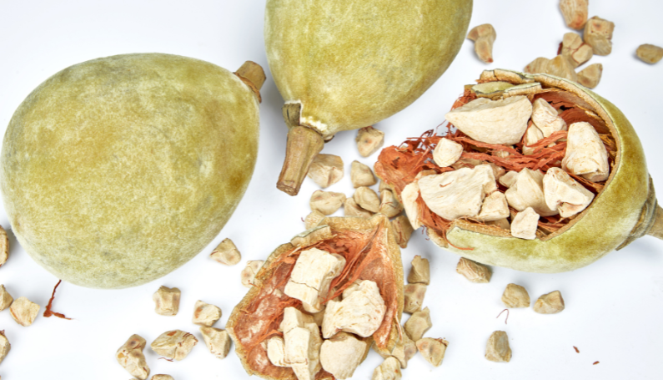

What is Organic Baobab Powder?
Organic baobab powder is made from baobab fruit harvested and processed according to certified organic standards.
This means the trees grow in their natural environment without synthetic fertilisers, pesticides, or GMOs, and the fruit is handled using clean, chemical-free processing methods. The powder is simply extracted from the dried pulp, sieved, and packaged — no additives or preservatives are required.
Certified organic baobab powder offers assurance for consumers and manufacturers focused on clean-label formulations.
Certifications such as USDA Organic confirm that the product meets strict agricultural and processing guidelines, making it ideal for health food brands, supplement companies, and retailers looking to align with ethical sourcing and natural wellness trends.

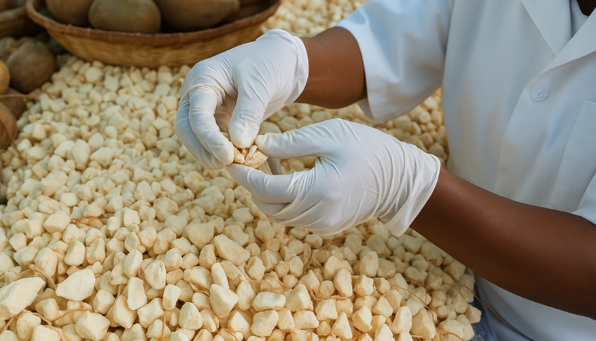

What Does Baobab Powder Taste Like?
Baobab powder offers a distinctive sensory experience with its pleasantly tangy flavor profile complemented by subtle natural sweetness.
This unique taste is often compared to a blend of pear, vanilla, and grapefruit, creating a versatile flavor that harmonises well with sweet and savory applications.
The powder's balanced sweet-tart profile makes it exceptionally adaptable in various food and beverage formulations. It pairs well with smoothies, yogurts, and juices while providing subtle depth to baked goods, energy bars, and savory sauces.
This distinctive yet compatible flavor profile is why baobab has gained popularity among health-conscious consumers and commercial product developers seeking functional ingredients that still taste delicious.

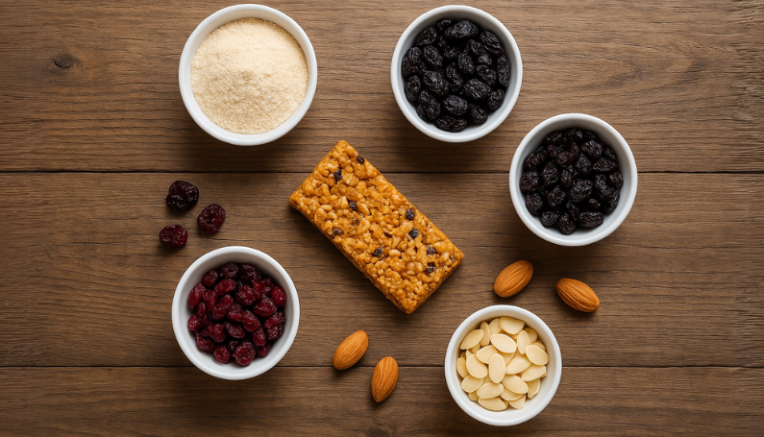

How is Baobab Powder Made?
The production of baobab powder starts with harvesting mature fruit that has naturally dried on the tree.
This natural drying process eliminates the need for artificial heat or preservatives. Once harvested, the fruit’s hard outer shell is cracked open to reveal the dry, crumbly pulp, seeds, and fibrous filaments.
The baobab fruit pulp is separated from the inedible components, then mechanically milled and finely sieved to produce a smooth, consistent and fine powder. No chemicals or additives are used at any stage, which helps preserve the fruit’s naturally high levels of fibre, vitamin C, and antioxidants.
The result is a clean, functional ingredient ideal for health-conscious consumers and clean-label product development.
If you are curious about the complete process and how baobab powder can be produced sustainably, explore our sustainable baobab powder production guide.

Chapter 2: The Anatomy of the Baobab Fruit

Understanding the baobab fruit's physical structure reveals its powder's origin.

This chapter examines each component, including the shell, pulp, seeds, and filaments, providing essential context for the benefits and applications discussed later.

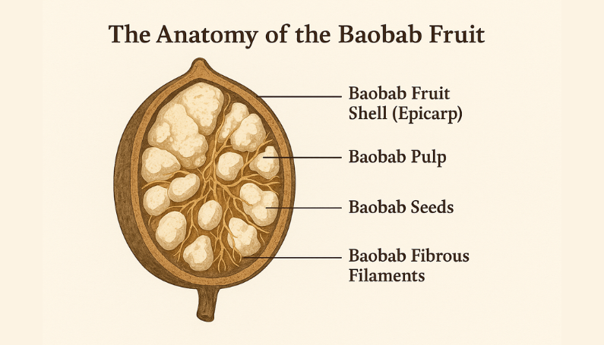

The Baobab Tree
The baobab tree is a remarkable, long-living species native to the semi-arid regions of Africa.
Known for its thick, bottle-shaped trunk and sparse crown of branches, it can live for over a thousand years and is well adapted to survive harsh drought conditions.
Its size, longevity, and resilience have made it a cultural icon across the continent, often called the “Tree of Life.”
Baobabs are uniquely adapted to their environment.
Their expansive root systems help them access deep water reserves and stabilise dry, erosion-prone soils. The trees also store water in their trunks during the rainy season, allowing them to withstand long periods of drought.
These natural adaptations reduce the need for irrigation or intensive care, making baobabs well-suited to low-input, regenerative agriculture.
For communities and suppliers focused on sustainable sourcing, the tree’s ability to thrive in degraded landscapes adds environmental and economic value.

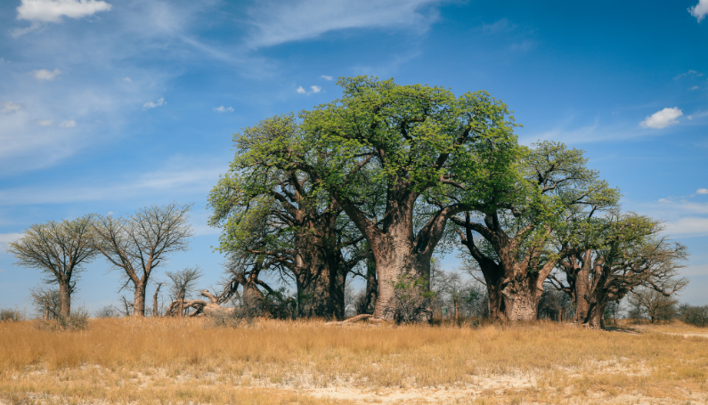

Baobab Fruit Shell (Epicarp)
The outer shell of the baobab fruit, known as the epicarp, is a hard, woody casing that protects the fruit’s interior as it matures and naturally dries on the tree.
This tough exterior plays a key role in preserving the pulp, shielding it from moisture, pests, and environmental damage during the drying process.
In botanical terms, the epicarp is the outermost layer of the pericarp, which refers to the entire fruit wall. The epicarp forms a thick, durable shell surrounding the pulp and seeds in baobab.
Oval in shape and covered in a soft, velvety coating, it typically measures 15 to 20 centimetres in length. During harvesting, the shell is manually cracked open using simple tools to reveal the dry, crumbly pulp inside — a process that reflects the fruit’s naturally low-intervention handling from Baobab tree to baobab powder.

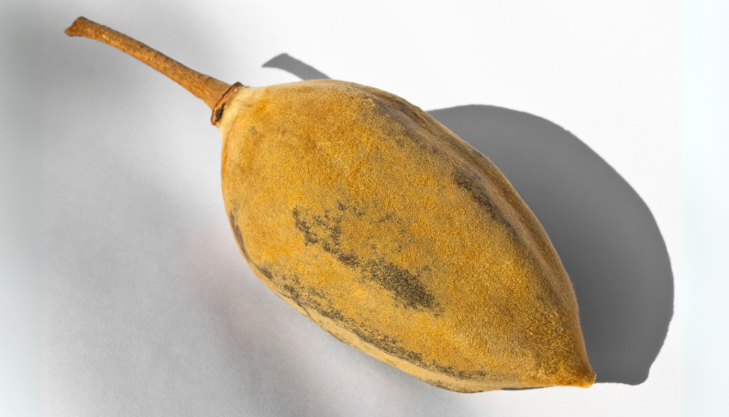

Baobab Pulp
Baobab pulp is the pale, dry material surrounding the seeds inside the baobab fruit.
It has a naturally crumbly texture and slightly chalky feel, forming in irregular chunks that break apart easily when handled. This inner pulp makes up the bulk of the fruit’s volume and protects the seeds while also contributing to the fruit’s self-preserving qualities.
Nutritionally, the pulp is exceptionally dense.
It is known for its high vitamin C content, as well as significant levels of dietary fibre, potassium, magnesium, and polyphenols.
These naturally occurring nutrients make the pulp one of the most valuable components of the baobab fruit, supporting its reputation as a functional ingredient across food, supplement, and wellness categories.

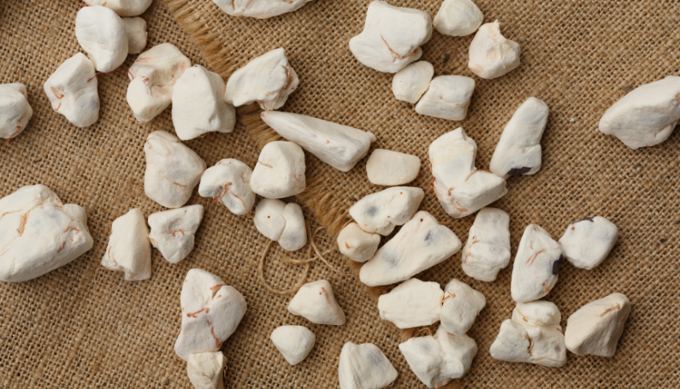

Baobab Seeds
Baobab seeds are hard, dark brown, kidney-shaped structures embedded within the fruit pulp.
Each fruit contains dozens of seeds, tightly packed and surrounded by the crumbly inner pulp. While they are not typically used to produce baobab powder due to their density and texture, they are an important by-product of the harvesting process.
The seeds hold significant value in other applications, particularly in the production of baobab seed oil.
This oil is cold-pressed from the seed kernels. It is highly prized in the skincare and cosmetics industry for its high content of omega fatty acids, antioxidants, and moisturising properties.
As interest in natural and ethically sourced ingredients grows, baobab oil continues to gain popularity in clean beauty formulations.

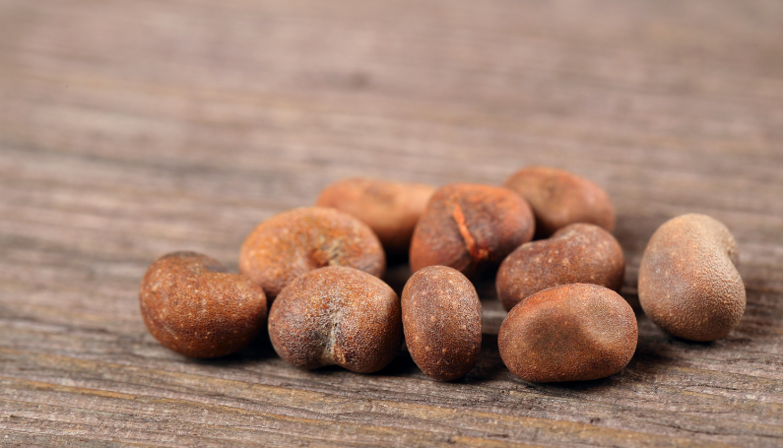

Baobab Fibrous Filaments
Baobab fibrous filaments, also called funiculi, are reddish, thread-like strands that connect each seed to the inner shell of the fruit.
These fibres are interwoven with the dry pulp and help suspend the seeds, giving the baobab fruit its distinctive internal structure and fibrous appearance.
Although they contain natural dietary fibre, the filaments are typically removed during processing to produce a smooth, uniform powder.
While not used in most consumer products, they contribute to the fruit’s total fibre profile and are an important part of the separation process during powder production.
Their presence highlights the baobab fruit’s complex natural design and nutrient-rich composition.

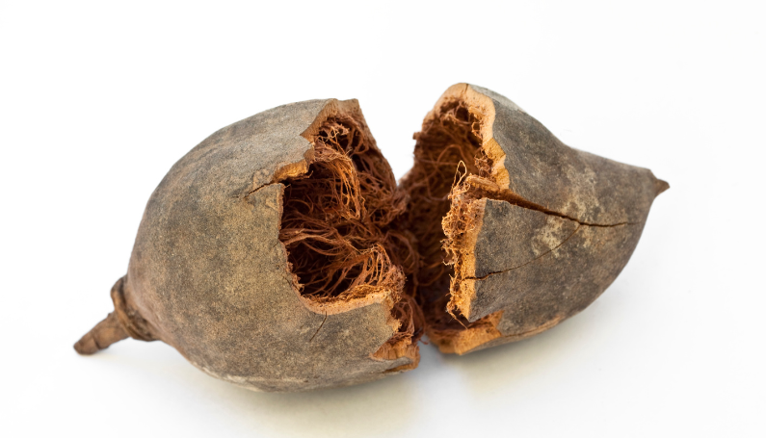

Chapter 3: The Science-Backed Benefits of Baobab Powder

Scientific research has documented baobab powder's impressive nutritional profile and the benefits it can offer consumers.

This chapter explores how this superfood supports immunity, digestion, energy, skin health, and blood sugar regulation through its natural functional properties and bioactive compounds.

High in Vitamin C for Immune Support
Baobab powder is exceptionally rich in vitamin C, providing 280–300 mg per 100g serving, up to seven or ten times more than oranges, strawberries, or other common fruits.
This makes it one of the most concentrated natural sources of vitamin C and a valuable addition to any wellness-focused diet.
Vitamin C plays a key role in supporting immune function. It helps protect cells from oxidative stress, strengthens the body’s natural defences, and reduces tiredness and fatigue.
These properties make baobab powder ideal for smoothies, juices, supplements, and functional food formulations designed to support daily vitality.

Rich in Natural Dietary Fiber for Gut Health
Baobab powder is a naturally high source of soluble dietary fiber, with just one tablespoon (10 grams) providing up to 18% of the daily recommended value.
This fiber helps regulate bowel movements, supports intestinal function, and promotes overall digestive balance when consumed regularly.
Incorporating baobab powder into daily meals can also help reduce bloating and improve digestive consistency.
Its gentle fiber profile makes it easy to tolerate, even for those with sensitive systems. It is a valuable addition to smoothies, oats, or yogurt for anyone seeking more digestive support from whole food ingredients.

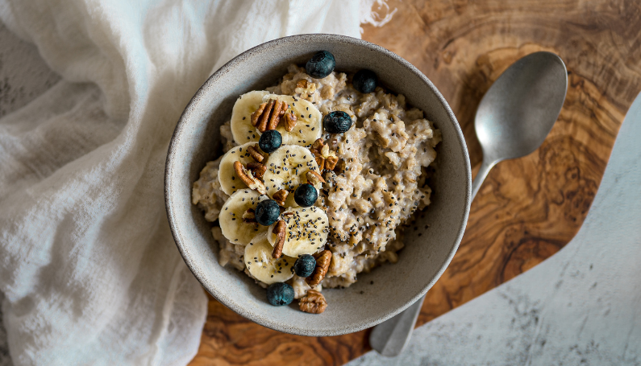

Helps Stabilize Blood Sugar Levels
Baobab powder supports blood sugar control in two key ways: it’s high in soluble fiber, which slows the absorption of sugars during digestion, and it contains naturally occurring polyphenols, which may further improve the body’s glycemic response after meals.
A recent clinical study found that consuming baobab extract significantly reduced post-meal blood sugar spikes in healthy adults.
Researchers suggest that its effect may be linked to its fiber content and bioactive compounds, such as procyanidins, which are thought to support insulin secretion and slow glucose absorption.
These findings support baobab’s potential as a functional ingredient for energy balance, appetite control, and blood sugar management.

Promotes Healthy Skin and Collagen Production
Baobab powder is a natural and rich source of vitamin C, a key nutrient in collagen synthesis.
Collagen is essential for maintaining skin elasticity, hydration, and overall firmness, making vitamin C-rich ingredients like baobab a valuable addition to skin-supporting diets.
Vitamin C is necessary for the body to build collagen properly - without it, collagen cannot form its strong, stable structure. Since humans cannot produce vitamin C naturally, we must get it from our diet for healthy skin and tissue repair.

Research into biochemical processes following tissue damage indicates that vitamin C plays a significant role in promoting collagen formation and accelerating the healing of soft tissues. This suggests baobab's high vitamin C content may support not just skin health but also recovery from exercise and injury.
In addition to vitamin C, baobab contains antioxidant compounds that help reduce oxidative stress.
Oxidative stress is a primary factor contributing to skin aging, and protecting against it can support a more youthful, resilient complexion.



Natural Antioxidants That Fight Inflammation
Antioxidants provide numerous benefits beyond skin health.
In baobab powder, naturally occurring compounds like polyphenols and vitamin C help neutralise free radicals, which are unstable molecules that contribute to inflammation and cellular damage over time.
Research on baobab red fiber (funicles), a structural component of the baobab fruit, highlights its exceptionally high antioxidant capacity.
The ORAC (Oxygen Radical Absorbance Capacity) value measures a substance’s ability to neutralise free radicals and reduce oxidative stress.

The higher the ORAC value, the stronger the substance's antioxidant capacity.

Baobab fruit powder has an impressive ORAC value of 16,800 units per 100 grams, highlighting its exceptional antioxidant potential.

For comparison, goji berries (dried) have an ORAC value of 9,750, acai (freeze-dried powder) scores 8,400, and blueberries (dried) come in at 7,530.
These values highlight baobab’s superior antioxidant power, making it an excellent choice for promoting long-term wellness and protecting against oxidative damage.
Baobab’s antioxidants help support immune function, ease joint discomfort, and may reduce the risk of chronic conditions such as heart disease, metabolic syndrome, and inflammatory disorders.

May Support Weight Management
Baobab powder is naturally high in dietary fiber, with 38.5g of carbohydrates per 100g serving, primarily from fiber.
This high fiber content can promote satiety, helping to curb appetite and reduce feelings of hunger after meals.
A study involving 20 healthy participants found that consuming a smoothie containing 15 grams of baobab extract significantly reduced subjective hunger ratings compared to a control smoothie.
These findings suggest that incorporating baobab powder into your diet may aid in weight management by enhancing feelings of fullness.​
This sense of fullness may make avoiding unnecessary snacking or overeating easier throughout the day.
In addition to promoting fullness, baobab powder supports steady blood sugar levels and promotes regular digestion. These combined effects help maintain balanced energy levels and appetite control.
Baobab powder is valuable to sustainable weight management routines, especially when paired with a healthy, active lifestyle.

Nourishes the Microbiome as a Prebiotic
Baobab powder contains soluble dietary fiber, primarily composed of pectic polysaccharides, which act as a natural prebiotic, helping to feed and support the growth of beneficial bacteria in the gut.
In fact, baobab fruit pulp powder has been shown to contain 42.5% soluble fiber by dry mass, predominantly in the form of low methoxylated pectic polysaccharides.
These soluble fibers stimulate the growth of beneficial gut bacteria, essential for maintaining microbial diversity.
A healthy microbiome is crucial for a resilient and well-functioning digestive system, and it’s linked to more substantial immune function, improved nutrient absorption, and the production of neurotransmitters that influence mood and cognitive performance.
The prebiotic effect of baobab fiber supports the gut environment by encouraging the growth of beneficial bacteria, such as Bifidobacteria and Lactobacilli, which are important for overall gut health.
By supporting gut health, baobab powder contributes to digestive and systemic health, promoting a balanced, well-functioning microbiome essential for long-term wellness.



Chapter 4: Consumer Guidance and Usage Recommendations

Maximise the benefits of baobab powder with practical advice for daily use.

This chapter provides recommended serving sizes, simple ways to incorporate baobab powder in meals and beverages, and important considerations for various consumer groups.

How Much Baobab Powder Should You Take Daily?
A typical daily serving of baobab powder ranges from 5 to 10 grams, or about 1 to 2 teaspoons. This amount is generally well tolerated and provides meaningful nutritional benefits, including fibre, vitamin C, and antioxidants.
For those new to baobab, it is best to start with smaller quantities, around 1 teaspoon, and gradually increase as your digestive system adjusts. This is especially important if your diet is low in fibre, as baobab is naturally high in soluble fibre.
The serving size may also depend on your health goals.
Larger servings may suit those seeking digestive support or increased antioxidant intake, while smaller amounts may complement an already nutrient-rich diet.
Always check product-specific recommendations and consult a healthcare provider for dietary concerns or medical conditions.

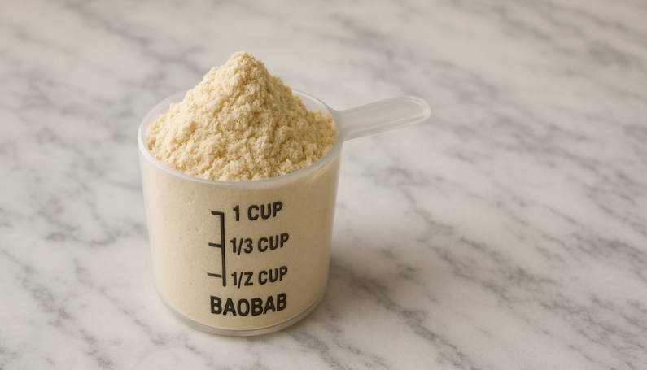

Practical Ways to Incorporate Baobab Powder Into Any Diet
Baobab powder is easy to use and naturally complements a wide range of everyday foods.
While specific serving sizes for baobab powder can vary based on individual dietary needs and product formulations, general guidelines for incorporating it into various foods are as follows:​
- Smoothies and Juices: Add approximately 10 grams (about 1 tablespoon) of baobab powder. This quantity provides a substantial boost of vitamin C and fiber.
- Yogurt and Breakfast Bowls: Mix in 5 grams (around 1 teaspoon) to enhance flavor and nutritional content without overwhelming the dish.​
- Baking (Muffins, Granola Bars, Energy Bites): Incorporate 10 grams (approximately 1 tablespoon) per serving to enrich the recipe with nutrients and a subtle tangy taste.​
- Oats and Porridge: Stir in 10 grams (about 1 tablespoon) to increase fiber content and add a pleasant tartness.​
- Protein Shakes and Supplements: Blend in 10 grams (roughly 1 tablespoon) to support digestive health and provide a natural source of vitamin C.​
For precise serving sizes, especially when considering specific health conditions or dietary plans, consulting with a healthcare professional or a registered dietitian is recommended.
These quantities are based on general recommendations and can be adjusted according to personal taste preferences and nutritional goals. It's advisable to start with smaller amounts to assess individual tolerance, especially for those new to baobab powder.​
It also works well in sauces, dressings, and plant-based dairy products, improving texture and boosting prebiotic content. Thanks to its heat stability and solubility, Baobab can be used in cold and cooked applications without compromising its nutritional value.
For those interested in commercial applications, we explore the uses of baobab powder in a related article about product ideas for manufacturers and producers.

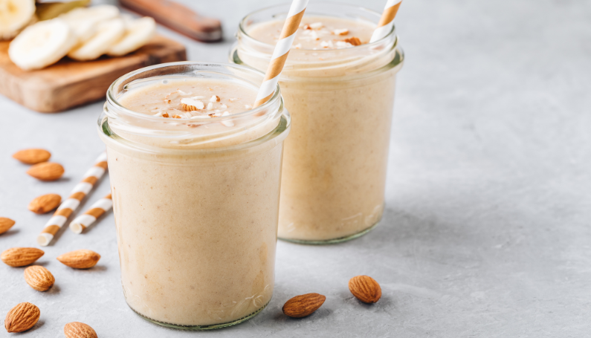

Is baobab powder safe for everyone?
Baobab powder is generally well-tolerated and considered safe for most people when consumed in typical dietary amounts.
It is a natural, minimally processed ingredient that fits well into clean-label and whole-food diets.
However, individuals with underlying health conditions or those who are taking medication should speak to a healthcare provider before introducing new functional foods into their diet.
This is especially relevant for pregnant or breastfeeding individuals, young children, and those with sensitive digestive systems, as the high fiber content may cause discomfort in large quantities.
Starting with small servings is advised for anyone new to using baobab powder.
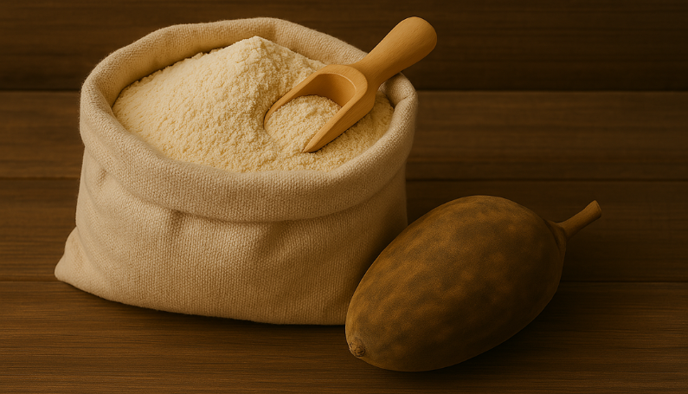

Chapter 5: Understanding the Baobab Powder Market

Navigate the growing baobab powder market with essential industry insights.

This chapter maps key production regions, analyses global trends in demand, profiles leading suppliers, and reveals emerging commercial opportunities across food, beverage, and personal care sectors.

Where Baobab Powder Comes From: Key Production Regions
Baobab trees are native to the semi-arid zones of sub-Saharan Africa, where they grow in hot, dry climates with seasonal rainfall.
The most prominent production areas stretch across West, East, and Southern Africa.
In West Africa, countries like Senegal, Ghana, Mali, and Nigeria are major exporters, with baobab deeply rooted in local food and wellness practices. Nigeria alone accounts for a market size of USD 15.99 million in 2024, with baobab powder sales expected to grow at a CAGR of 5.4%, driven by both domestic use and exports.
East African nations such as Kenya and Tanzania are also expanding their harvesting networks, often through community-led initiatives that support sustainable practices and local economies.
Southern Africa plays a growing role, with significant baobab populations in Zimbabwe, Malawi, and South Africa contributing to commercial harvests. In South Africa, the baobab powder market is valued at USD 24.06 million in 2024. It is projected to grow at a CAGR of 7.3%, boosted by consumer demand for natural and sustainable products.
While the tree grows naturally across these regions, environmental factors such as rainfall patterns, soil conditions, and temperature influence the fruit’s development and yield.
Together, these areas form the backbone of global baobab powder production.

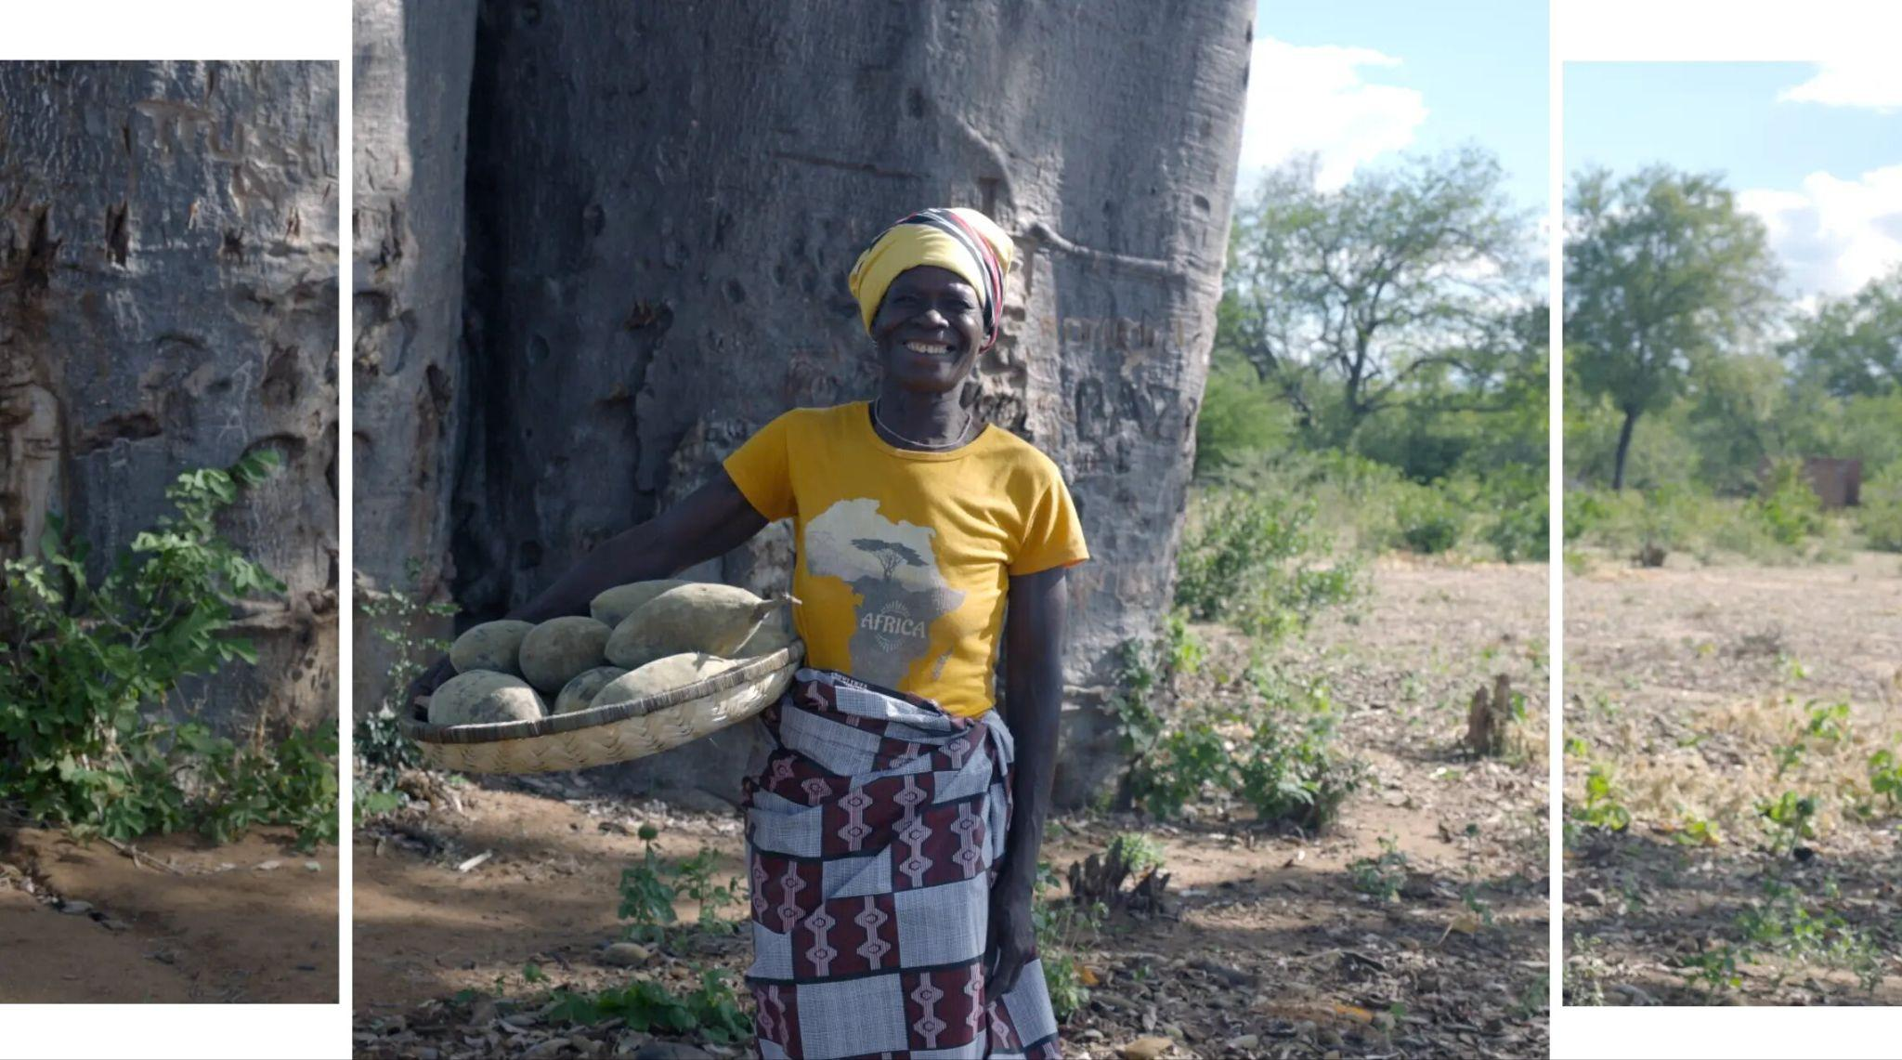

Image description: Rosa Baera Savier, one of the women who collects baobab fruit by hand.

Key Markets For Baobab Powder & Growth Outlook
Demand for baobab powder is steadily increasing in global health and wellness markets, led by the United States and the European Union.
These regions are at the forefront of innovation, with growing interest in plant-based nutrition, antioxidant-rich ingredients, and clean-label product development.
In 2020, North America accounted for 41% of global market revenue, reflecting strong consumer adoption and the presence of leading brands.
According to Research and Markets, the global baobab powder market was valued at $9 billion in 2024 and is expected to grow at a compound annual growth rate (CAGR) of 5% through 2030.
Emerging markets in Asia-Pacific, the Middle East, and parts of Africa are also gaining traction as awareness of baobab’s nutritional benefits and sustainability profile continues to expand across categories like food, beverages, and nutraceuticals.

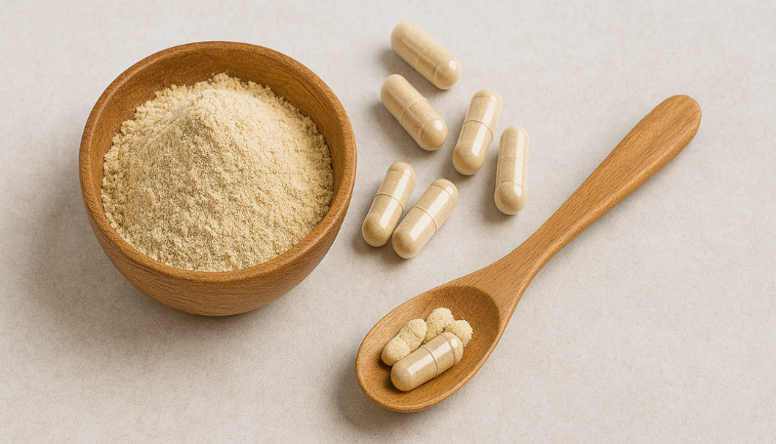

Key Companies in Baobab Powder Production
The baobab powder market is supported by a combination of community-based enterprises and international suppliers who are committed to quality, sustainability, and responsible sourcing.
Throughout the industry, production is governed by a range of certifications and quality standards, ensuring that products meet both environmental and ethical expectations.
Across various regions, baobab producers adhere to certifications such as USDA Organic, EU Organic, Fair for Life, Fair Trade, and COSMOS Organic. These standards ensure that baobab powder is sustainably sourced, ethically harvested, and free from harmful chemicals, providing consumers with a high-quality, traceable product.
Other relevant certifications include Non-GMO Project Verified, which guarantees that baobab powder is free from genetically modified organisms, and ISO 22000, ensuring that production processes meet international food safety management standards.
Key producers in the industry include Aduna, B'Ayoba, NP Nutra, EcoProducts, and Atacora. These companies have earned recognition for their dedication to ethical sourcing, environmental sustainability, and the promotion of local economies in baobab-producing regions.
A standout leader in the global baobab powder market is Baobest (Baobab Foods). Based in the United States and partnered with harvesters across Africa, Baobest is known for its premium-quality, certified organic baobab powder.
Our company maintains a strict focus on responsible sourcing with a transparent and traceable supply chain, ensuring that the environmental and social impacts of production are well managed.
Baobest's commitment to quality is reflected in its adherence to global certifications, such as USDA Organic, EU Organic, and Fair for Life. These certifications guarantee that Baobest's baobab powder meets rigorous standards for sustainability and ethical practices.
In addition, Baobest is dedicated to community impact, working with local farmers and harvesters to ensure fair labor practices and support for local economies.
For brands seeking to formulate with certified organic, nutrient-rich baobab powder, Baobest offers scale and reliability, making it a preferred wholesale supplier for the food, beverage, and wellness sectors.



Market Trends And Alignment With Healthy Foods & Beverages
The rise of the clean-label movement is reshaping the food and beverage industry.
Consumers are increasingly looking for products made with recognisable ingredients, minimal processing, and no artificial additives.
This shift is driven by a broader desire for transparency, trust, and wellness, especially among younger, health-conscious shoppers.
Baobab powder fits seamlessly into this trend.
It’s a single-ingredient, naturally dried fruit powder that delivers functional nutrition without adding sugars, preservatives, or synthetics. Its nutritional density and organic credentials make it a natural choice for brands formulating clean-label snacks, functional beverages, and wellness products.
Beyond clean-label compatibility, baobab also meets growing sustainability and social responsibility expectations.
The fruit is wild-harvested using low-impact methods, and many suppliers work directly with rural communities to promote ethical sourcing and local development. This dual focus on product integrity and positive impact enhances brand storytelling and supports long-term consumer loyalty.
Baobab powder’s alignment with these trends positions it as more than just a superfood—it’s a catalyst for innovation across the global health and wellness market.

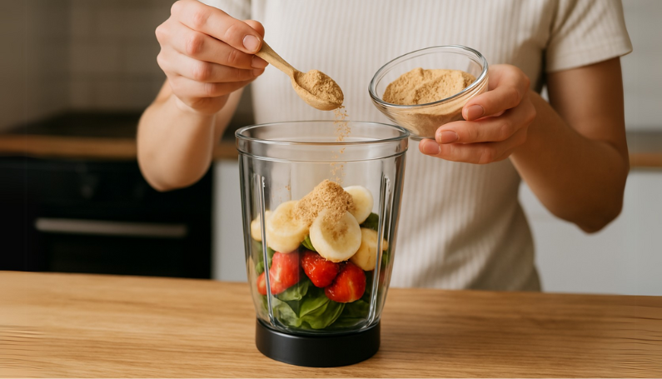

Where to Buy Baobab Powder in Wholesale Quantities

For product developers, retailers, and manufacturers requiring bulk baobab powder, several reliable wholesale channels exist:

- Direct from African Producers - Companies like Baobab Foods and EcoProducts offer direct sourcing from harvesting regions in countries such as Senegal, Malawi, South Africa and Zimbabwe.

- Specialty Ingredient Distributors - Wholesalers like Nutri-Organic, Ingredients by Nature, and Global Goods Inc. supply premium baobab powder to North American and European markets.

- International Trade Platforms - B2B marketplaces, including Alibaba and TradeKey connect buyers with verified baobab suppliers globally. However, it is essential to conduct additional vetting to ensure supplier reliability and product quality. Refer to the next section on selecting the right supplier, where we outline key criteria to consider during your vetting process.

- Regional Distributors - Find a baobab powder supplier in the US or source from European wholesalers through specialized regional guides.

How to Select the Right Baobab Powder Supplier
When evaluating potential wholesale partners, consider these essential factors:

- Quality Certifications - Look for suppliers offering USDA Organic, Fair Trade, or Non-GMO Project Verified products to meet consumer and regulatory expectations.

- Harvesting Practices - Prioritize suppliers demonstrating sustainable wild harvesting methods that protect baobab tree populations and support ecosystem health.

- Supply Chain Transparency - Select partners who provide complete documentation on product origin, processing methods, and quality testing results.

- Minimum Order Requirements - Verify that order minimums align with your production needs while optimising inventory costs. For example, Baobest typically offers bulk orders starting at 100 kg up to over a ton, while other suppliers may require a minimum of 500 kg for international orders.

- Pricing Structure - Compare not just base pricing but shipping costs, payment terms, and volume discount options across potential suppliers.

- Processing Standards - Suppliers operating their own processing facilities typically maintain superior quality control compared to aggregators.

In related articles, we explore how to find a baobab powder supplier in the US, and Europe.

Baobest: Your Premium Wholesale Partner

Baobest stands out as a premium wholesale supplier serving North American and international markets with several unique advantages.

Baobest maintains established relationships with rural African harvesting communities, ensuring ethical sourcing while supporting local economies. We control our entire supply chain from harvest to processing, delivering consistent powder quality and complete traceability.

Our comprehensive certification portfolio includes USDA Organic, Non-GMO, Kosher, and Fair Trade options. With scalable supply capability, we are equipped to support both specialty product launches and high-volume manufacturing requirements with reliable year-round availability.

Our team also provides product education and marketing support to help wholesale partners maximize baobab powder's potential in their product lines.

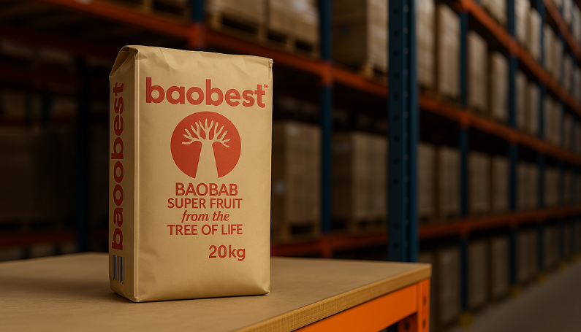

Final Thoughts on Baobab Powder
Baobab powder has quickly become a sought-after superfood, thanks to its exceptional nutrient profile and wide range of health benefits.
As consumer demand for natural, nutrient-dense ingredients grows, baobab's versatility in food, beverages, and wellness products makes it a valuable asset for manufacturers and consumers alike. Its high fiber, vitamin C, and antioxidant content support overall health, making it an ideal addition to clean-label products and functional foods.
As the market continues to expand, the sustainability and ethical sourcing practices of baobab powder are gaining increased attention, ensuring alignment with both environmental and social responsibility goals.
At Baobest, we provide sustainably produced, 100% organic baobab powder to producers for applications such as food manufacturing. We also supply companies that sell baobab powder online or in-store worldwide.
Our baobab powder is wild-harvested, empowering local communities by supporting livelihoods and improving living standards. It is also backed by certifications, including USDA Organic, EU Organic, Canada Organic, and more.
We encourage you to learn more about our bulk organic baobab powder and contact us if you’d like to place an order.
In related content covered on our blog, you can also learn more about baobab powder, including what is involved in a sustainable production process, its nutritional profile, and its benefits for food manufacturing. Our science library also provides scientific insights into this incredible superfruit.

